ISO/IEC JTC1/SC7/AHG6 “Digital Engineering”
Convenorship: BIS
Convenor: Oberoi Sundeep Dr
AHG Report – Digital Engineering

Document type | Related content | Document date | Expected action
General document/other | N/A | 2021-11-30 | INFO

Replaces: N/A
Description
Report of the Ad Hoc Group on Digital Engineering V 1.0

Ad Hoc Group Report
Digital Engineering
November - 2021
Version 1.0

Background
In a meeting on October 12, 2021, ISO/IEC JTC1/SC7 invited International Council on Systems Engineering (INCOSE) Digital Engineering Information Exchange Working Group (DEIX WG) members to form an Ad Hoc Group for conducting a study and report on the background and opportunities for standardization in the field of Digital Engineering.
The terms of reference for this Ad Hoc Group (AHG) are thus to:
- Provide background information on the field of Digital Engineering and the status of activities in this area.
- If pertinent, make recommendations for the creation of standards in this area.
Additional guidance for the AHG:
- The INCOSE DEIX WG, currently working in this area, should be approached for potential participation in this Ad Hoc Group.
- The Ad Hoc membership should be complete by September 3, 2021.
- The first virtual meeting to be held in October 2021, to present INCOSE’s current work plan and potential deliverables to the AG6.
- Report to be made available on November 30, 2021 prior to the ISO/IEC December plenary meeting.
The Ad Hoc Group will be chaired by Dr. Sundeep Oberoi (SC7 Chair).
Others who joined the Ad Hoc Group are:
- Sean McGervey (INCOSE DEIX WG Chair)
- Celia Tseng (INCOSE DEIX WG Co-chair, INCOSE Standards Framework Work Products Co-chair)
- Frank Salvatore (INCOSE DEIX WG Co-chair)
- Scott Goodman
- Wanda Eyre

Important Note
The contributing members of this study group have provided inputs from several cited sources and their own analyses. The study group does not endorse this information but simply collates it. This report is intended for use by the ISO/IEC community to determine standardization efforts and is not intended to be used for any other purpose.

Table of Contents
1. Introduction 6
1.1. Digital Transformation 6
1.2. Engineering Information Exchange 6
2. Problem Statement 6
3. Digital Viewpoint Model 9
3.1. DEIX WG DVM Background 10
3.2. DVM Concept Model 10
3.3. Digital Artifact 11
3.4. Digital Viewpoint 13
3.5. Process 14
3.6. Stakeholder 15
3.7. Digital Viewpoint Model Summary 16
4. Standards 16
5. Recommendation 17
6. Glossary 17
7. References 17

Introduction

Digital Transformation
The fourth industrial revolution, the digital revolution, is transforming engineering and many other disciplines across the globe. This digital transformation is affecting engineering in industry, government, and academia.
The term Digital Engineering generally refers to the digital transformation of engineering to leverage digital technologies. “The crux of digital engineering is the creation of computer readable models to represent all aspects of the system and to support all the activities for the design, development, manufacture, and operation of the system throughout its lifecycle [1].”

Engineering Information Exchange
As more organizations and disciplines move towards a holistic, integrated Digital Engineering (DE) approach, there is a growing need to share, cross-reference, integrate, reuse, and extend models of various kinds to digitally represent a total system model.
And although system models have been used for decades, this constitutes transforming engineering information exchange from traditional approaches for exchanging documents to model-based approaches for exchanging digital artifacts.
A digital artifact is any combination of professional data, information, knowledge, and wisdom (DIKW Pyramid) expressed in digital form and exchanged within a digital ecosystem. A digital artifact may be descriptive model elements, database records, query records, unstructured text fields, software modules, geometric primitives, video frames, audio frames, or any combination of these and other sets of professional DIKW.
Industries and governments are grappling with a currently disjointed use of those models. As such, industries now have the added challenge of exchanging engineering information in a new digital environment, while addressing issues like tool interoperability, model language and standards, obsolescence, workforce development, and organization cultural change.

Problem Statement
Digital Engineering Information Exchange (DEIX) is difficult because it is fundamentally about Data Analysis: “a process of inspecting, cleansing, transforming, and modeling data with the goal of discovering useful information, informing conclusions, and supporting decision-making [2].”

For a single model, data analysis is made easier because the elements of the model are semantically related to each other via the rules established by the model’s governing metamodel, as exemplified below.

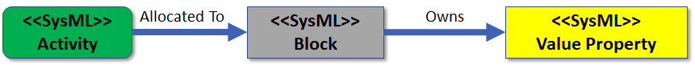
Figure 2-1: Single Model Type and Model

But… how can we semantically relate elements between different models, when they each have their own metamodel and rules?

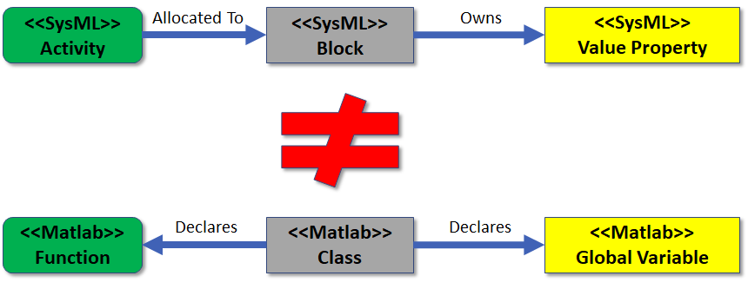
Figure 2-2: Single Model Type and Multiple Models

And the problem of conceptually relating heterogeneous data elements grows exponentially as we add more types of models to the mix.

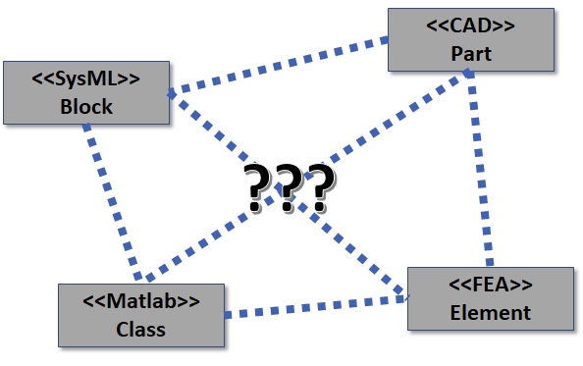
Figure 2-3: Multiple Model Types and Models

Unfortunately, relating elements between models can be difficult, even for models with the same metamodel… For example, a SysML <<Block>> can represent an infinite number of concepts, as shown on the left side of Figure 2-4. Conversely, a single concept can be represented in an infinite number of ways, as shown on the right side of Figure 2-4.

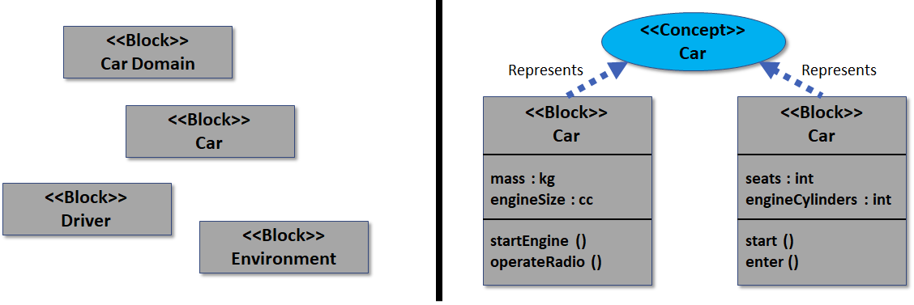
Figure 2-4: Mapping Schema

One solution is to create a mapping schema to relate elements, but as with integrating multiple simulations, that can only be done if the elements are conceptually relatable.

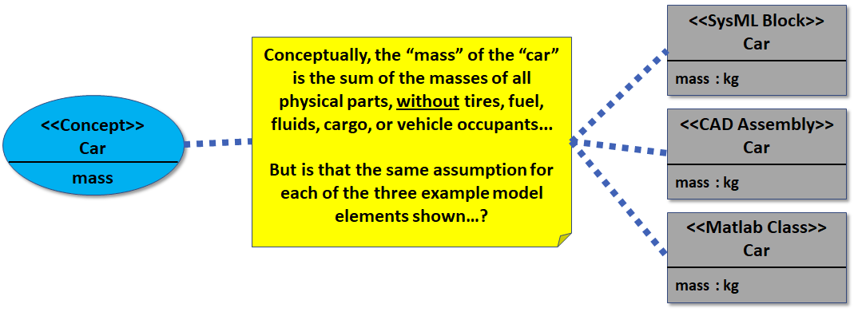
Figure 2-5: Example of Multiple Model Types and Models

Additionally, even if our organization or business unit assembles a digital engineering ecosystem (DEE) that manages to conceptually relate its various authoritative sources of truth… How do we exchange its digital information with a different DEE that may have different concepts…?

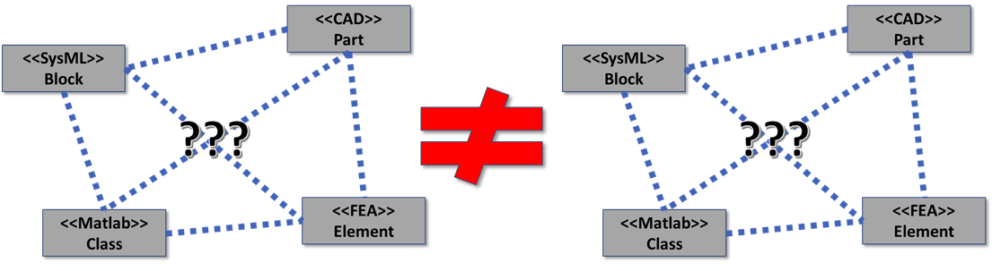
Figure 2-6: Multiple Model Types, Models, and Ecosystems

Digital Viewpoint Model
The objective of the DVM concept model is to characterize the content and relationships involved in the exchange of digital artifacts and its curation for stakeholder use and consumption. The Digital Engineering Information Exchange Working Group (DEIX WG) developed this concept model to describe the interactions and challenges of exchanging a diverse set of information in a digital environment. The DEIX WG is a collaboration between the International Council of Systems Engineers (INCOSE), the National Defense Industry Association (NDIA) Modeling and Simulation (M&S) Subcommittee, and the Department of Defense, Office of the Under Secretary for Research and Engineering (DoD/OUSE (R&E)). The DEIX WG supports the strategic objective to accelerate the digital engineering transformation by evolving the characterization of the content and relationships involved in the exchange of digital artifacts between disciplines and stakeholders throughout the engineering lifecycle.

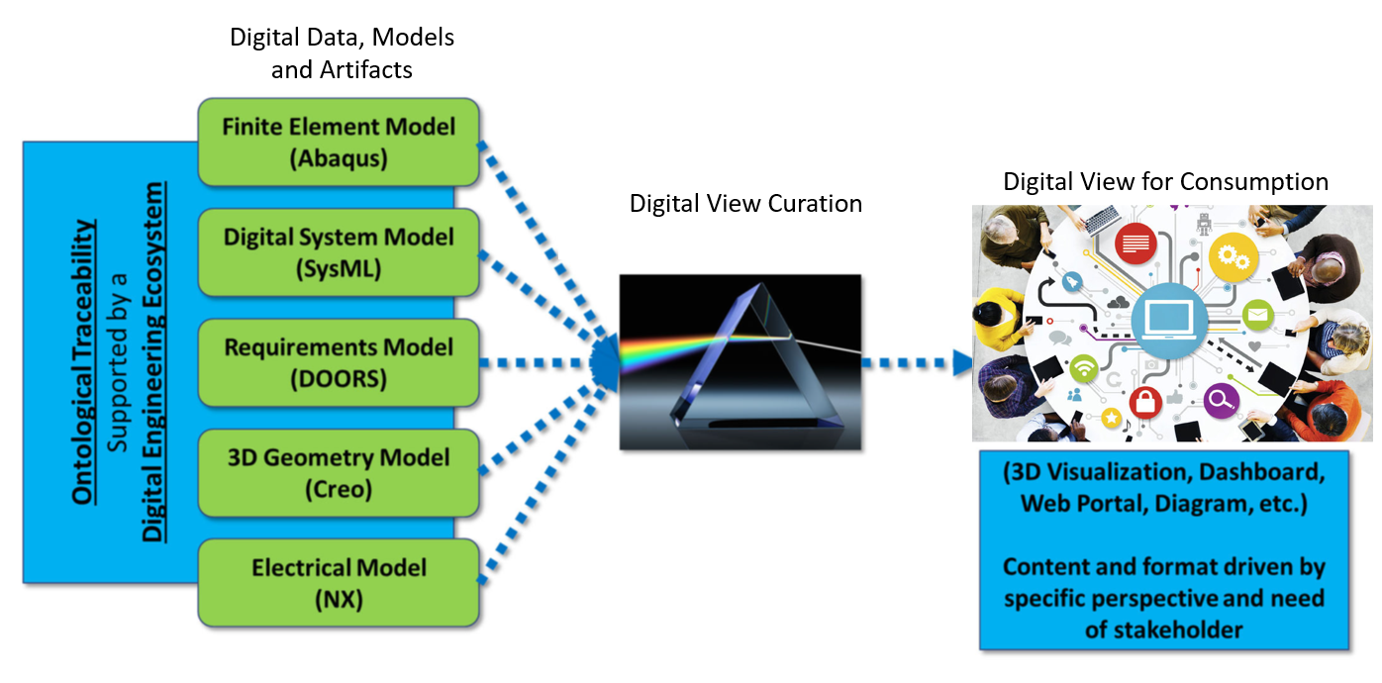
Figure 3-1: Transformation of Digital Information

The transformation of digital information to digital views for any purpose begins in the digital engineering ecosystem where the digital data and models are generated. Examples of such purposes include, but are not limited to, program milestone reviews, requirements validation, design trade studies, risk analysis, product verification, day-to-day interaction during program execution, authoritative source of truth integration.
A digital engineering eco-system is defined as a set of interconnected digital environments, stakeholder networks, and sematic data that allows the exchange of digital artifacts from an authoritative source of truth. The digital engineering environment supports the unique requirements of each discipline that has a role in producing authoritative data and models for its enterprise. It also serves as the means to curate digital views and artifacts from the authoritative sources to aid stakeholder collaboration and decision-making.

DEIX WG DVM Background
The initial groundwork for the Digital Viewpoint Model (DVM) began in 2018. The NDIA Modeling & Simulation Committee sponsored a two-day Digital Artifacts Workshop where the focus was to define how digital models can interoperate to support data exchange between two parties, an acquirer and a provider. The participants divided into three teams to analyze the perspectives of an acquirer, provider, and the conceptual modeling of digital artifacts for exchange. The outputs from the workshop were used to create the first draft of the DVM Concept Model during the 2019 INCOSE International Workshop (IW). The team gained consensus on the DVM Concept Model at the 2019 NDIA Systems and Mission Engineering Conference, and launched an open DEIX Challenge in July 2020 to seek proposed implementations and extensions of the DVM Concept Model. The challenge results was presented at the Virtual 2020 NDIA Systems and Mission Engineering Conference. The concepts presented in this paper are the emerging thoughts and consensus from these activities.

DVM Concept Model
The DVM Concept Model in Figure 3-2 captures high level concepts needed to describe the definition and relationships for digital information exchange. It is divided into four main concepts: digital artifact, digital view, process, and stakeholder. The concepts are related to each other and provide a common language for specifying the content of a digital view for user consumption within a digital engineering ecosystem.

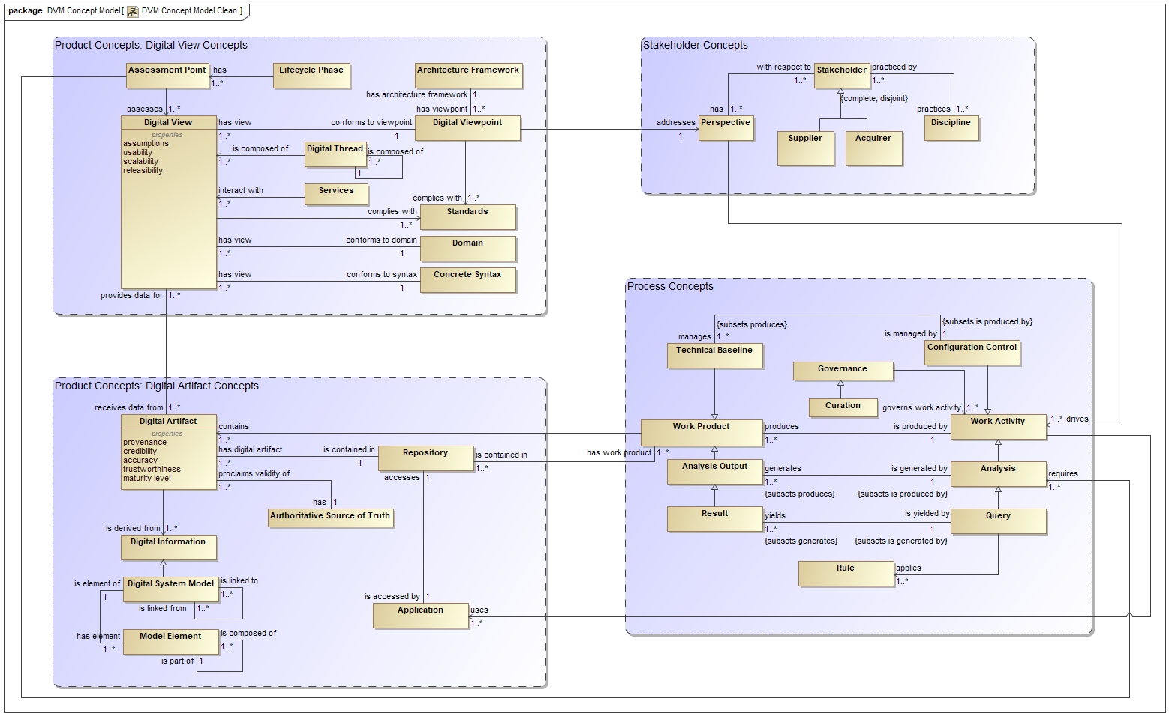
Figure 3-2: DVM Concept Model

These four main concepts are discussed below.

Digital Artifact
The digital artifact concept in Figure 3-3 provides definitions and guidance on its development for a specific user scenario. A digital artifact is any combination of professional data, information, knowledge, and wisdom (DIKW) expressed in a digital form and exchanged within a digital ecosystem.
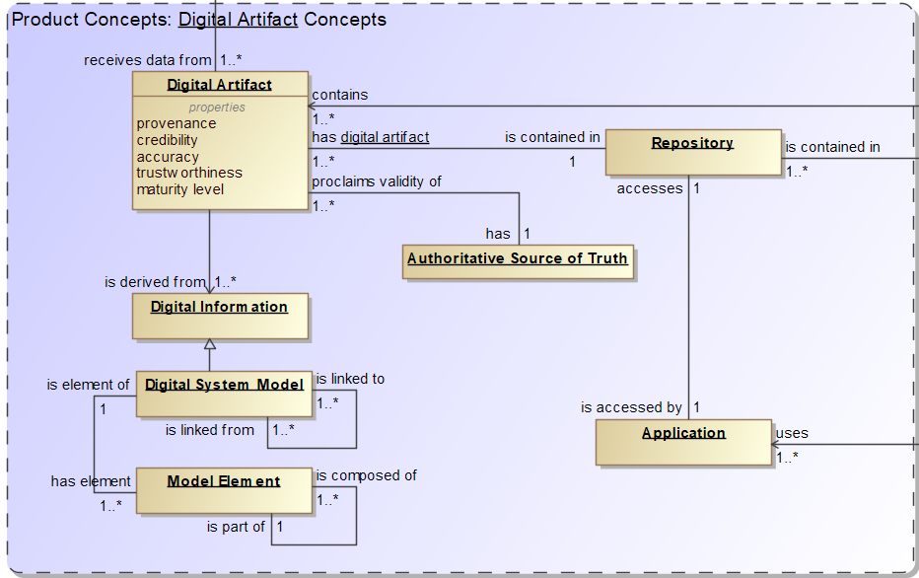
Figure 3-3: DVM Concept Model: Product Concepts

To distinguish the digital artifact from raw digital data and models, the DEIX WG established eight characteristics of a digital artifact, as shown in Figure 3-4.
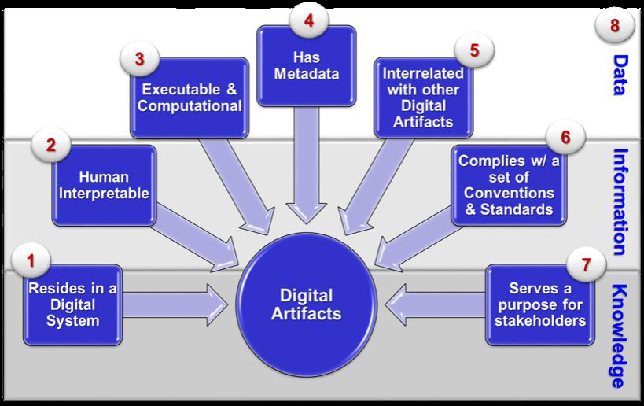
Figure 3-4: Digital Artifact Characteristics

A digital artifact encapsulates DIKW of collection of authoritative models and data generated by various stakeholder disciplines. It can serve as a token for value exchange with other stakeholders or digital systems. The digital artifact is part of the authoritative source of truth since it is comprised of authoritative data and models. Since the possible combinations for digital artifact generation is endless, those requesting the digital artifact generation must have a standard way of describing its construct and desired format for consumption.

Digital Viewpoint
The digital viewpoint concept in Figure 3-5 describes the various stakeholder perspectives when viewing a digital artifact in a presentation format. It uses conventions, formalisms and standards to define the systematic procedures to select, compile, layout, and present digital artifacts such that it meets stakeholders’ unique needs. The digital viewpoint can be comprised of multiple digital views to address a user perspective. The digital view is a visual presentation on an electronic display device consisting of one or more processed digital artifacts, enabling the consumption of digital artifact content according to stakeholders’ unique activities at any phase or step in the system life cycle.

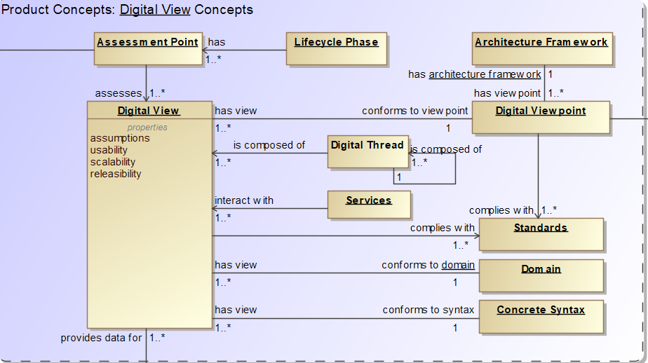
Figure 3-5: DVM Concept Model: Digital View Concept

Process
The process concept in Figure 3-6 describes the work flow processes in developing digital artifacts. The output of a work activity produces work products and forms a technical baseline managed by configuration control. A governing process provides the evidence that the digital information contained in a work product is an authoritative source of truth. When the governing process registers a work product as part of the authoritative source of truth, it is available for consumption by a broader stakeholder community.

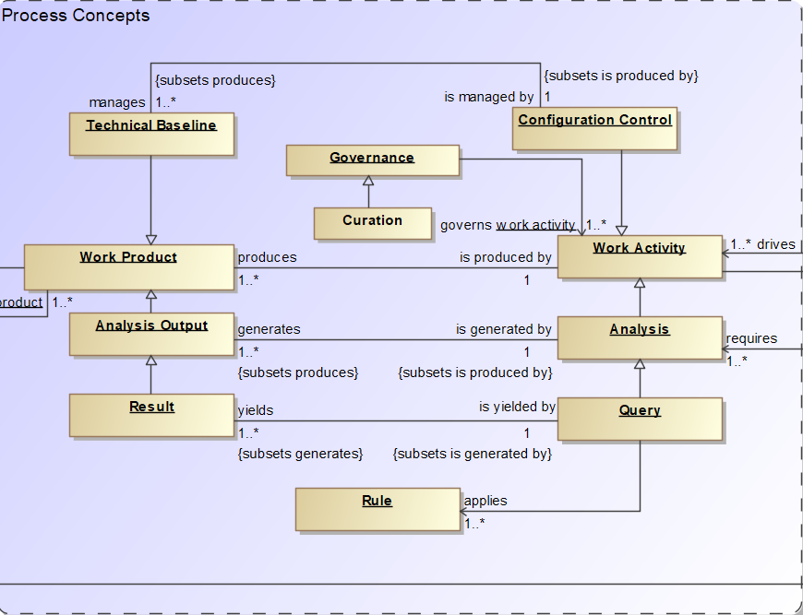
Figure 3-6: DVM Concept Model: Process Concepts

Stakeholder
The stakeholder concept in Figure 3-7 provides definitions and interactions of the stakeholders viewing the digital artifacts, as well as their motivations and objectives. Stakeholders have a unique perspective shaped by their background discipline and their organizational role. The stakeholder may practice one or more disciplines, and may include engineering and non-engineering functions. The supplier of the digital views and artifacts uses conventions, formalisms and standards to curate the data and information that meets the acquirer’s needs. The acquirer receives and consumes the digital view in order to perform their work activities.
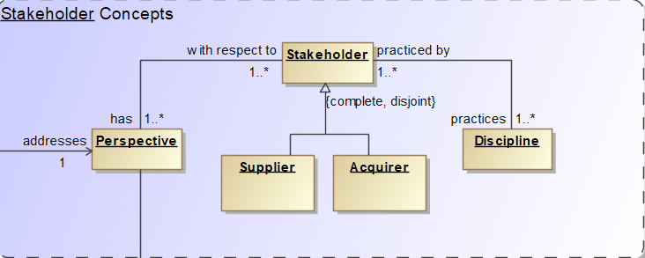
Figure 3-7: DVM Concept Model: Stakeholder Concepts

Digital Viewpoint Model Summary
Despite the tremendous advances of the digital age, there are still significant inefficiencies when exchanging engineering information with a traditional document-based approach, or a more contemporary model-based approach. The DEIXWG aspires to ensure that digital artifacts are transferable and consumable within industries. The DVM Concept Model seeks to model concepts pertaining to the curation and exchange of a set of digital artifacts in a digital engineering environment. The DEIX Challenge provided a vehicle for the refinement of the DVM Concept Model with stakeholder-defined concept extensions for assembling digital artifacts and information exchange.

Standards
The challenges of exchanging a diverse set of information in a digital environment across stakeholders with different perspectives and organizations with different interests is driving the formation of standards in a number of areas. These efforts include, but are not limited to, the Life Cycle Processes and Harmonization Working Group’s (LCPHWG) work in methods for SC7 modeling and correlation of standards for IDEF(0) process diagrams and artifacts, network diagrams, and taxonomy of standards [3].

Standards are needed for the four main concepts within the Digital Viewpoint Model – digital artifact, digital view, process, and stakeholder. Of these, the DEIXWG is focusing its efforts on the digital view and stakeholder concepts. Currently, the DEIXWG is defining use cases for digital views and viewpoints associated with stakeholder perspectives.

In 2018, IEC formed Strategic Group 12 (SG12) to address the issue of how machine readability would affect standards development. Two questions that are being investigated are 1) What is a model for a standard and 2) How can semantic ‘interoperability’ be achieved in standards. The answers to these questions can also be applied to the digital artifact concept.

Currently, INCOSE’s Configuration Management Working Group is investigating configuration management process concepts for digital engineering.

These are just some of the many efforts that are being in pursued around these four concepts of digital engineering – digital artifact, digital view, stakeholder, and process. However, there is no harmonizing structure for these efforts.

Recommendation
The Digital Viewpoint Concept Model integrates these four concepts in a holistic manner. As such, it should be used to integrate the various efforts in these areas.

Glossary
Glossary Terms | Description
DEIXWG | Digital Engineering Information Exchange Working Group
Digital Artifacts | Any combination of model data and meta-data that are exchanged within a digital ecosystem.
Digital View | A visual presentation on an electronic display device consisting of one or more processed digital artifacts, enabling the consumption of digital artifact content according to stakeholders’ unique activities at any phase or step in the system life cycle.
Digital Viewpoint | A digital view that uses conventions, formalisms and standards to define the systematic procedures to select, compile, layout, and present digital artifacts in a digital ecosystem such that it meets stakeholders’ unique needs.
DVM | Digital Viewpoint Model
DoD/OUSE (R&E) | Department of Defense Office of the Under Secretary of Research and Engineering
INCOSE | International Council on Systems Engineering
IW | International Workshop
NDIA | National Defense Industry Association

References
[1] Guide to the Systems Engineering Body of Knowledge, Digital Engineering.
[2] "Transforming Unstructured Data into Useful Information", Big Data, Mining, and Analytics, Auerbach Publications, pp. 227–246, 2014-03-12, doi:10.1201/b16666-14, ISBN 978-0-429-09529-0, retrieved 2021-05-29
[3] LCPHAG_N0087 Brief for Strategic Planning-AG - LCPHAG (v2 - 18 May 2012).
DEIX Working Group website http://www.omgwiki.org/MBSE/doku.php?id=mbse:deix
Office of the Deputy Assistant Secretary of Defense for Systems Engineering, "Digital Engineering Strategy," U.S. Department of Defense, Washington, DC, 2018.
C. Zins, "Conceptual approaches for defining data, information, and knowledge," Journal of the Association for Information Science and Technology, vol. 58, no. 4, pp. 479 - 493, 2007.
D. L. Howell, "OMB MBSE Wiki: Digital Engineering Ecosystem," Object Management Group (OMG), 7 December 2018. Available at http://www.omgwiki.org/MBSE/doku.php?id=mbse:digital_engineering_ecosystem.
T. Hambrick and J. Madsen, "OMG MBSE Wiki: Digital Thread," Object Management Group (OMG), 1 November 2018. Available at http://www.omgwiki.org/MBSE/doku.php?id=mbse:digital_thread.
T. P. Alexander and J. H. Coleman III, "OMB MBSE Wiki: Authoritative Source of Truth," Object Management Group (OMG), 4 December 2018. Available at http://www.omgwiki.org/MBSE/doku.php?id=mbse:authoritative_source_of_truth.
J. H. Coleman III, "OMG MBSE Wiki: Digital Viewpoint," Object Management Group (OMG), 12 December 2018. Available at http://www.omgwiki.org/MBSE/doku.php?id=mbse:digital_viewpoint.
J. H. Coleman III, "OMB MBSE Wiki: Digital View," Object Management Group (OMG), 8 November 2018. Available at http://www.omgwiki.org/MBSE/doku.php?id=mbse:digital_view.
J. H. Coleman, "MBSE Wiki: Digital Artifact," Object Management Group (OMG), 7 January 2019. Available at http://www.omgwiki.org/MBSE/doku.php?id=mbse:digital_artifact.
C. Delp, D. Lam, E. Fosse and C.-Y. Lee, “Model Based Document and Report Generation for Systems Engineering,” in IEEE Aerospace Conference Proceedings, Big Sky, Montana, 2012
Rhodes D.H., Interactive Model-Centric Systems Engineering Technical Report, Phase 5. SERC-2018-TR 104, Feb 28, 2018
Reymondet, L., Rhodes, D.H. & Ross, A.M. Considerations for Model Curation in Model-Centric Systems Engineering. 10th Annual IEEE Systems Conference. Orlando, FL, April 2016
National Academy of Science. Preparing the Workforce for Digital Curation. National Academies Press. 2015
ISO/IEC/IEEE, “42010 - 2011: Systems and software engineering – Architecture description,” International Organization for Standardization, Geneva, Switzerland, 2011.
S. Foo, T. Y. Leng, D. G. Hoe-Lian and N. J. Cheong, “From digital archives to virtual exhibitions,” in Handbook of Research on Digital Libraries: Design, Development and Impact, S. Foo, H. G. Dion and N. J. Cheong, Eds., Hershey, PA, IGI Global, 2009, pp. 88-101.
Wikipedia.org, “DIKW pyramid,” Wikimedia Foundation, Inc., 8 July 2018. [Online]. Available: https://en.wikipedia.org/wiki/DIKW_pyramid. [Accessed 5 September 2018].
C. Zins, "Conceptual approaches for defining data, information, and knowledge," Journal of the Association for Information Science and Technology, vol. 58, no. 4, pp. 479 - 493, 2007.
J. Rowley, "The wisdom hierarchy: representations of the DIKW hierarchy," Journal of Information Science, vol. 33, no. 2, p. 163–180, 2007.

